COURSE REGISTRATION - STUDENT INSTRUCTIONS

The portal can be accessed on campus using the link available on the wc@home page located under Academic Records, Student Portal Instructions. Or off campus via the Wilmington College website (www.wilmington.edu) using the “WC Portal” link which is located on the bottom of the page under Resources. Or by using the following URL: https://wcportal.wilmington.edu/ics

If you run into any problems or have any questions, please contact the Academic Record Coordinator in the Academic Records office at ext. 464 or 512 or email records@wilmington.edu.

Enter your NETWORK login and password
PLAN YOUR COURSE SCHEDULE BEFORE REGISTRATION BEGINS. ONCE YOUR REGISTRATION TIME/DATE IS AVAILABLE YOU WILL BE READY TO CHECKOUT AND GET YOUR COURSES REGISTERED.

TO REGISTER - Click My Academics, REGISTRATION located on the left side of the page.

- Click the My Academics tab; then select Student Registration
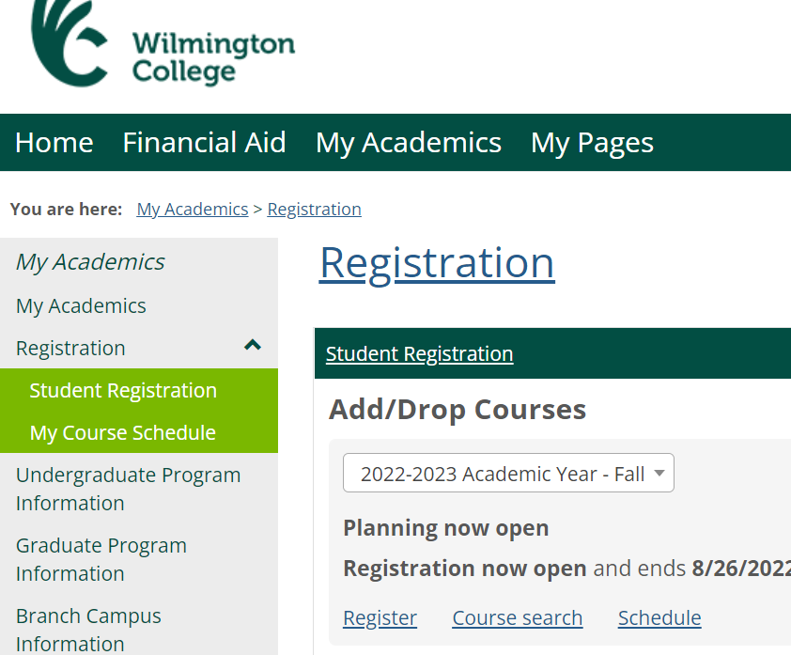

- Complete the Registration Agreement form each term.

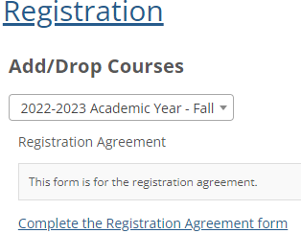

- Obtain Registration Clearance from advisor prior to registration.
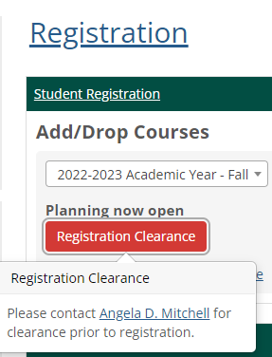

- Once you have completed the Registration agreement form and obtained permission to register from your advisor, click Register and the search panel and planning calendar appear

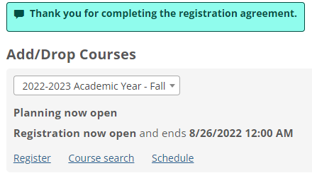

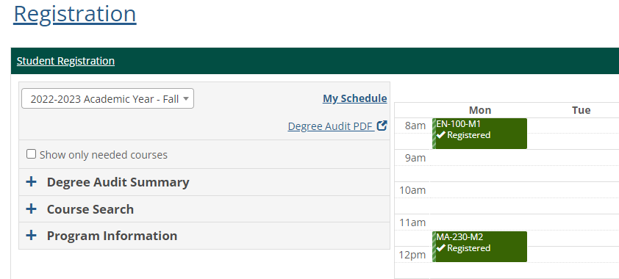
- Click Course Search
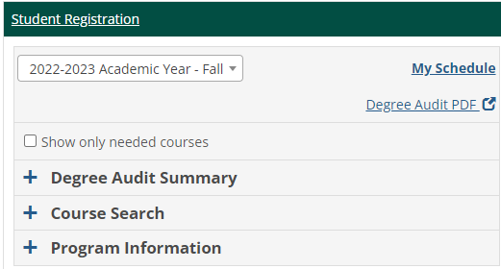

Course Search by one or more of the following criteria:
- Course Code or Title: For example: EN-101; note that courses have a dash (-) after the first two letters
- Instructor: Search by name: EX: McKay
- Department: Search by department: EX: Agriculture
- Location: EX: Main campus or Main campus graduate
- Section Status: Search by Open or full status
- Meets on Selected Days: M Tu W Th F Sa Su

- Select the course/section you want to register for
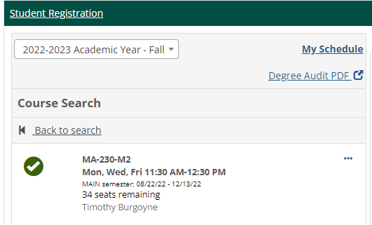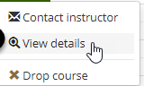

Develop Your Schedule
Once you find a section, you can view details, contact the instructor, or add it to your planning calendar. Adding it to your planning calendar doesn't register you; it just helps you plan. Work out your schedule by adding courses to your calendar, experimenting with various sections, until you find the combination that meets your requirements. During this process, you can register for some courses, request approvals and permissions for others, and keep others on your calendar without registering. Your calendar may include conflicts and warnings while you're in the planning stages. Your calendar saves automatically, and they will still be there next time you log in.

- Once you have your schedule planned, do not forget to check out. You will not be registered until you check out.

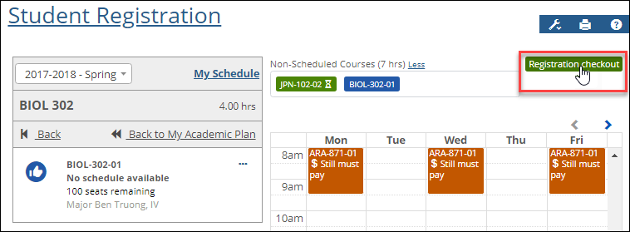
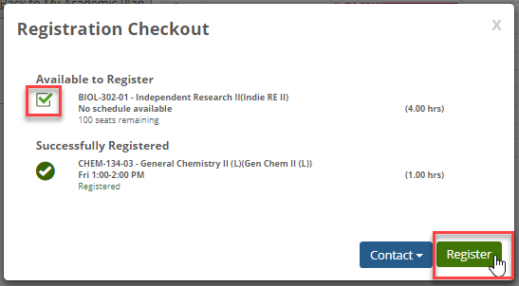

If registration isn't open yet, the button is inactive, and it's labeled Registration closed. At 5 minutes before registration opens, a countdown timer appears.
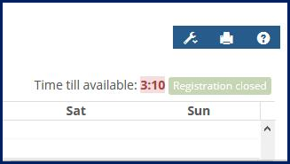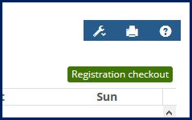
As soon as registration opens, the button label changes to Registration checkout. That's when you can click it to open the Registration Checkout page and complete your registration.

Resolving Issues with Registration

Non-Scheduled Courses
Some courses don't have a regular schedule, so they can't be placed on your calendar. Examples may include directed study, online courses, or courses whose schedules are not determined yet.
Nonscheduled courses appear in the search panel with the message "No schedule available" or "No schedule." When you add them to your schedule, they appear just above the calendar. The subtotal of hours for nonscheduled courses alone shows just above the courses. You can hide nonscheduled courses by clicking the Less link and show the courses again by clicking the More link.

Nonscheduled courses use the same colors and symbols as courses on the calendar, and they work just like scheduled courses for approvals, registration checkout, removing from the schedule, and dropping.

Variable Credits and Variable Grading Types
Some sections allow you to select the number of credits and/or the grading type. When you add such a section to your calendar, a pop-up lets you enter the number of credit hours you want and/or select a grading type.

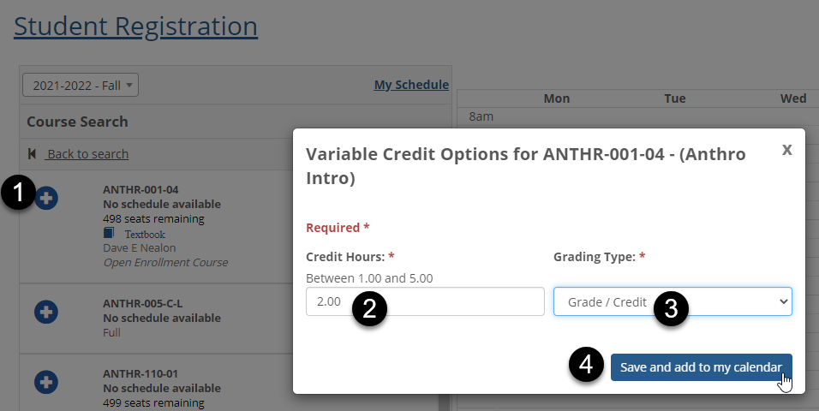

Resolve Issues (Clearance & Approvals)
Before you register, you can see whether any of your courses have issues to address. Then you can contact instructors and initiate advisor approvals and registration clearance.

Request Registration in a Full Section

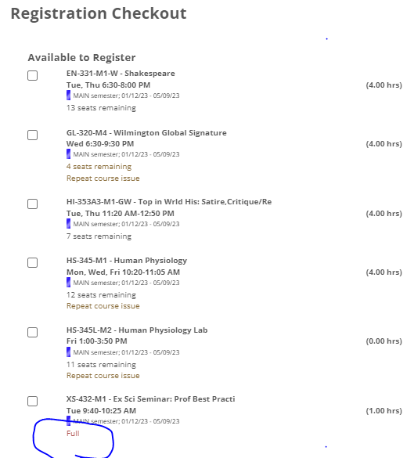
If a course is full, you may register for all other courses by checking the box and going to the Check Out to register. For the courses that are full, you may contact the instructor and ask if they can create a course-full override so you can register. Keep checking the status of the section on your calendar. If it's no longer full or if the instructor grants you a course-full override, then when you click the course, the 'Move to registered' option is available in the drop-down. Click it to register for the section.

How to Request Advisor Approval for a Course

If your advisor must approve any added courses, those courses are listed in the Awaiting Advisor Approval box. You can request advisor approval for those courses.
- On the Add/Drop page, select the courses that need approval.
- Click the Request Advisor Approval button.

- If you have more than one advisor, select the appropriate one, and then click the Send Email button.
- A message tells you that your advisor has been notified that your schedule is ready to be reviewed.

Register for a Course that has Corequisites

If a course has corequisites, register for the course and its corequisites together.
- Place the course and its corequisites on your calendar.
CH-230 (a lecture) and its lab, CH-230L. You place a section of CH-230 on your calendar. The red edge stripe indicates an issue, so you click the course and view the issue. Place the lab on your calendar.

Drop a Course that has Corequisites

When you try to drop a course that has corequisites, you're prompted to either drop all the corequisites at once or choose a replacement section for the course you're dropping. To drop the courses:
- Click the course on your calendar.
- Click Drop course. A warning message opens.
- Click the Yes radio button.
- Click Drop.
- A message asks if you want to drop the corequisite, too. Click the Yes radio button, and click Drop.
- Both courses are dropped and removed from your calendar.

Switch Sections of a Course that has Corequisites

Usually, to switch sections of a course, you simply drop the course and add a new section of it. But a course with corequisites is different because corequisites must be dropped together. If you only want to switch sections of one of the corequisites, you can do it without dropping the courses.
- On your calendar, click the course you want to switch.
- Click Drop course. A warning message opens.
- Click the No radio button.
- Use the Select a course drop-down to select a replacement section.
- Click Register.
Let's say, you want to change sections of your chemistry lab. Click the lab on your calendar and click Drop course. A warning message asks whether you want to drop both the lab and its corequisite. But you want to replace your lab with a different section, so you select a new section from the Select a Course drop-down. Then click Register.

